**User Guide: PowerConnect - City Grid Optimization**

**Application Overview**

The core purpose of this web application is to demonstrate and allow interaction with Kruskal's Algorithm, which is a popular technique for constructing a Minimum Spanning Tree (MST) in graph theory. In this application, the MST is visualized as a power grid that connects various cities while minimizing the total power cost.

Minimum Spanning Tree (MST)

Think of each city as a node, and each power line as a connection (edge) between cities with an associated cost (e.g., power usage or infrastructure cost).

The goal of the MST is:

* To connect all cities
* With the minimum total power cost
* And no unnecessary cycles or loops

Kruskal’s Algorithm

This is the technique used in the application to build the MST. It works by:

* Sorting all possible connections by power cost (ascending order).
* Adding the cheapest connection, unless it would create a cycle.
* Repeating this process until all cities are connected.

The application provides two interactive modes:

* Power Grid Simulation: Automatically generates a random network and demonstrates Kruskal's Algorithm.
* Custom City Network: Lets users build their own cities and connections and apply the algorithm.

**Detailed Walkthrough**

**A. General Layout**

Header: The top of the page shows the app name *"PowerConnect: City Grid Optimization"* along with a subtitle that briefly explains its goal.

Tabs: Directly below the header, two tabs allow you to switch between the two main modes:

Power Grid Simulation

Custom City Network

Main Content Area: This section changes depending on the selected tab, showing different controls and visualizations.

**B. Power Grid Simulation Tab**

This mode is designed for educational purposes to help users see Kruskal’s Algorithm step-by-step on a random network.

Instructions Box

Located at the top of the tab, this box gives a short explanation of Kruskal’s algorithm and the goal of the simulation.

Controls

Generate Random Cities

Generates a random layout of cities and potential power lines.

Cities are placed in a circle and labeled (e.g., "New York", "Chicago").

Edges between them have randomly calculated weights based on distance.

Run Algorithm

Starts the animation of Kruskal’s Algorithm.

You’ll see lines turn green (added), red (rejected), and yellow (being considered).

Next Step

Instead of automatic animation, lets you manually go through each step of the algorithm.

Reset

Clears the current network and resets all algorithm progress.

Animation Speed Controls

Speed Slider: Adjusts the animation speed from 1 (slow) to 10 (fast).

Pause: Freezes the algorithm mid-execution.

Resume: Resumes a paused animation.

Status Panel

Left Side: Displays the current step, e.g., “Processing connection between City1 and City2 (12 MW)”.

Right Side: Shows the Total Cost of the MST so far.

Graph Canvas

The heart of the simulation.

Cities (Nodes): Represented by circles labeled with city names.

Connections (Edges):

Green: Included in MST.

Red: Rejected due to forming a loop.

Yellow/Orange: Currently being considered.

Edge Weights: Shown in MW (megawatts), indicating power cost.

Power Line Connections Panel

A textual summary of all edges.

Columns:

Cities connected

Power Cost

Status (Connected, Rejected, Pending)

This panel updates live as the algorithm progresses.

Statistics Panel

Shows summary information:

Number of Cities

Possible Connections

Connected Lines (in MST)

Rejected Lines

Instruction Panel

Offers an educational explanation of Kruskal’s Algorithm:

Sorts all edges

Adds lowest-cost edge if it doesn't create a cycle

Repeats until all cities are connected

**C. Custom City Network Tab**

This mode allows you to build your own network of cities and simulate Kruskal’s Algorithm on it.

Instruction Box

Brief overview of what this tab allows you to do:

Add cities

Connect them

Run Kruskal’s Algorithm on your custom setup

Network Creation Tools

Mode Selection Buttons: These determine what clicking on the canvas will do:

Add City

Click anywhere on the canvas to place a city.

You can also enter a custom name.

Add Connection

First click a city, then another to connect them.

The power requirement (weight) is calculated based on distance.

Move City

Drag and reposition cities on the canvas.

Delete

Click on cities or connections to remove them.

Manual Input Forms

Add City:

Enter the name of the city.

Click "Add City" to place it randomly on the canvas.

Add Connection:

Choose source and target cities from dropdowns.

Specify the weight (e.g., 5 MW).

Click "Add Connection".

Use This Network:

Once the custom network is ready, click this to switch to the Power Grid Simulation tab with your custom layout.

Clear All:

Clears all cities and connections from the custom network.

City and Connection Lists

Cities Panel:

Shows all cities added manually.

Includes delete buttons.

Power Connections Panel:

Lists all connections.

Includes delete buttons and weights.

Input Canvas

The visual area where you build your custom network.

Cities can be placed, moved, and connected.

Connections show weights (in MW).

Edge lines and city circles behave similarly to the simulation tab.

**D. Step-by-Step Use Cases**

1. Explore a Random Simulation

* Open the HTML file in a browser.
* Stay on the Power Grid Simulation tab.

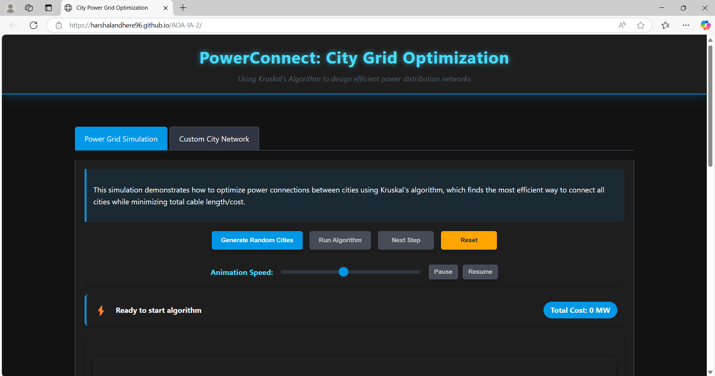

* Click Generate Random Cities.

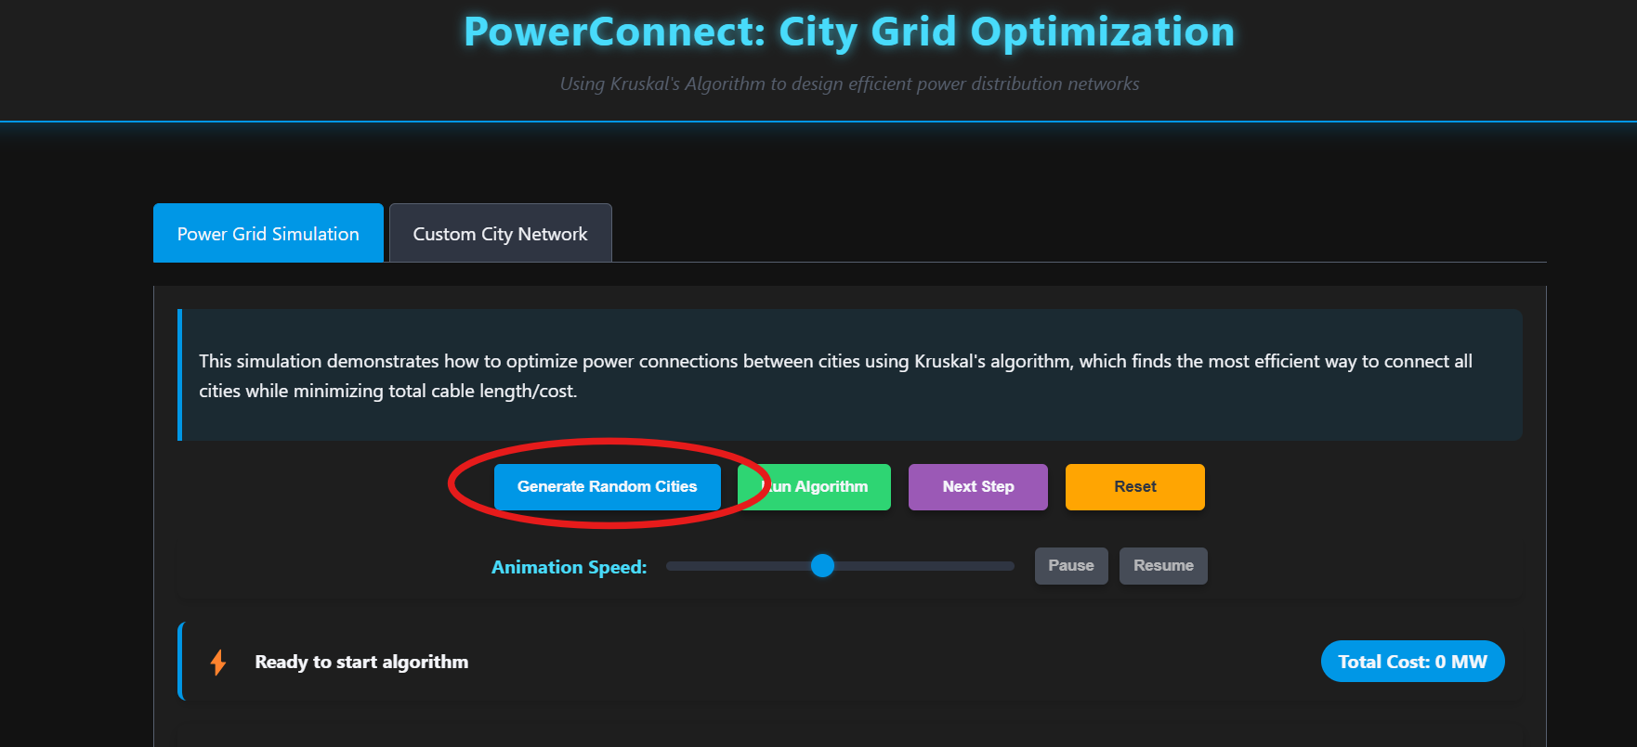

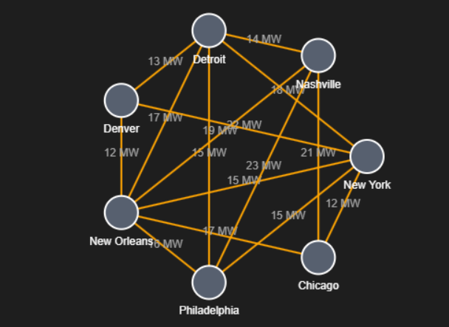

* Click Run Algorithm or Next Step to visualize Kruskal’s process.

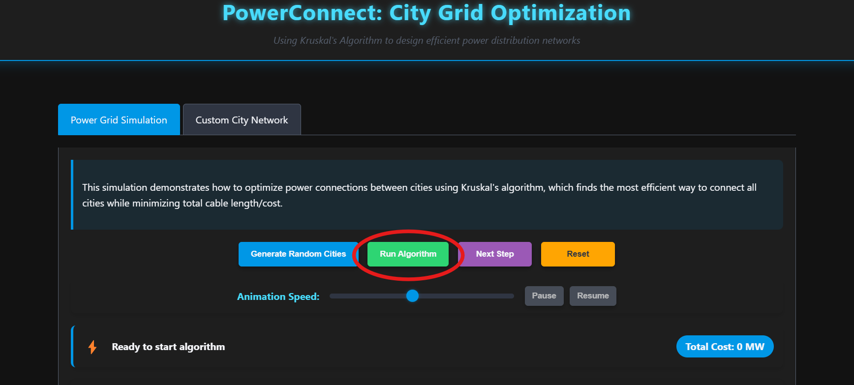

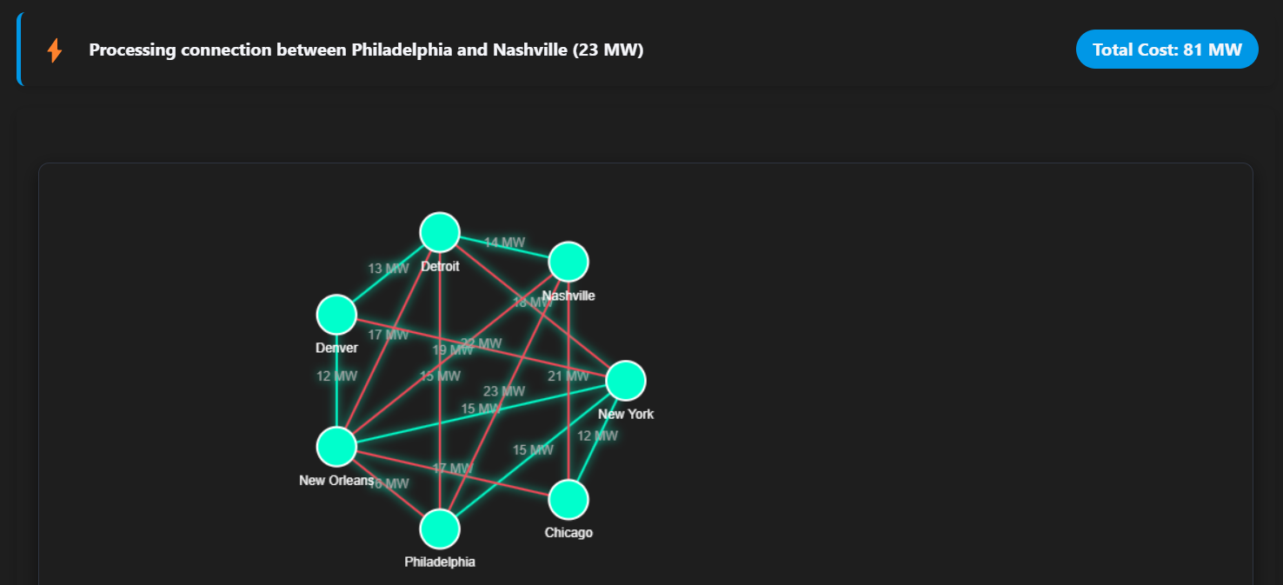

* Observe how colors change, and the edge list and cost update in real time.
* Click Reset to try again with a new random network.

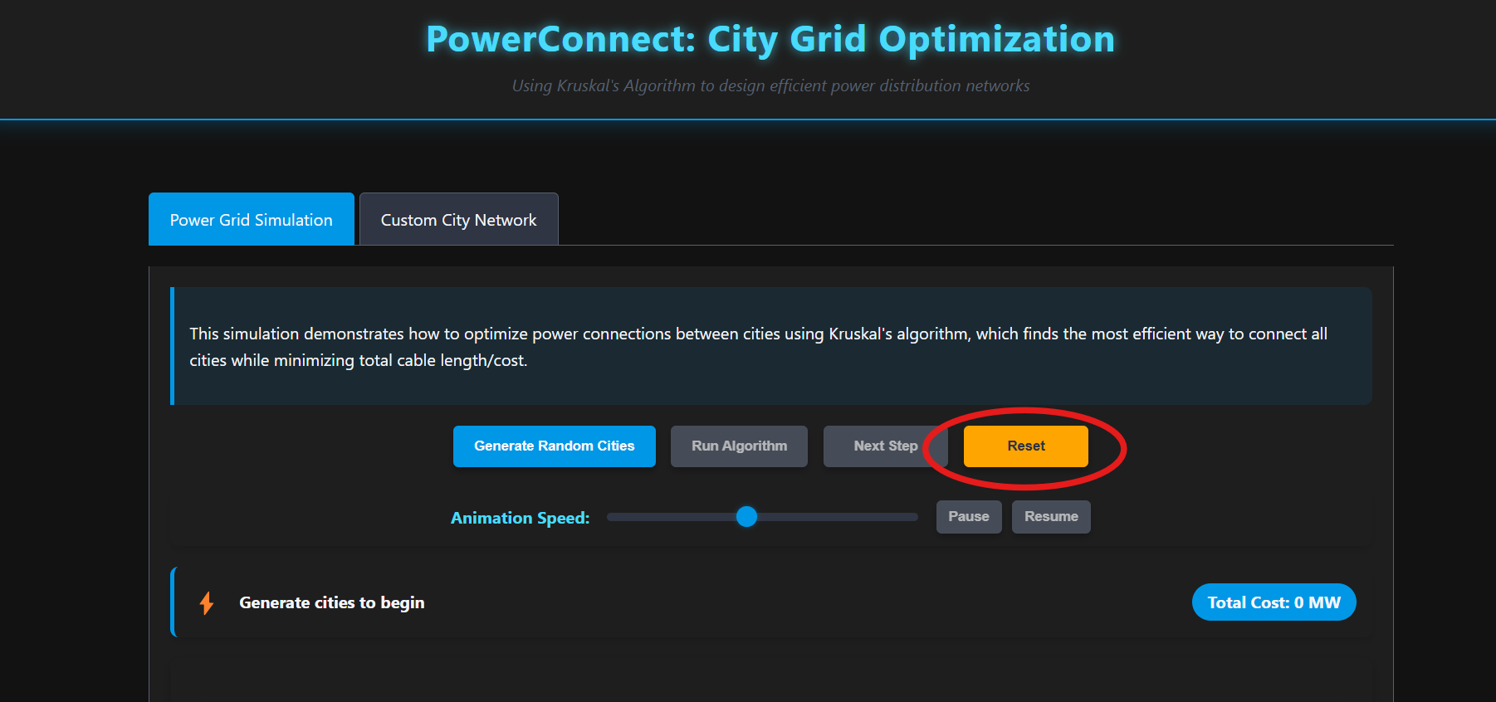

1. Create and Analyze a Custom Network

* Click the Custom City Network tab.

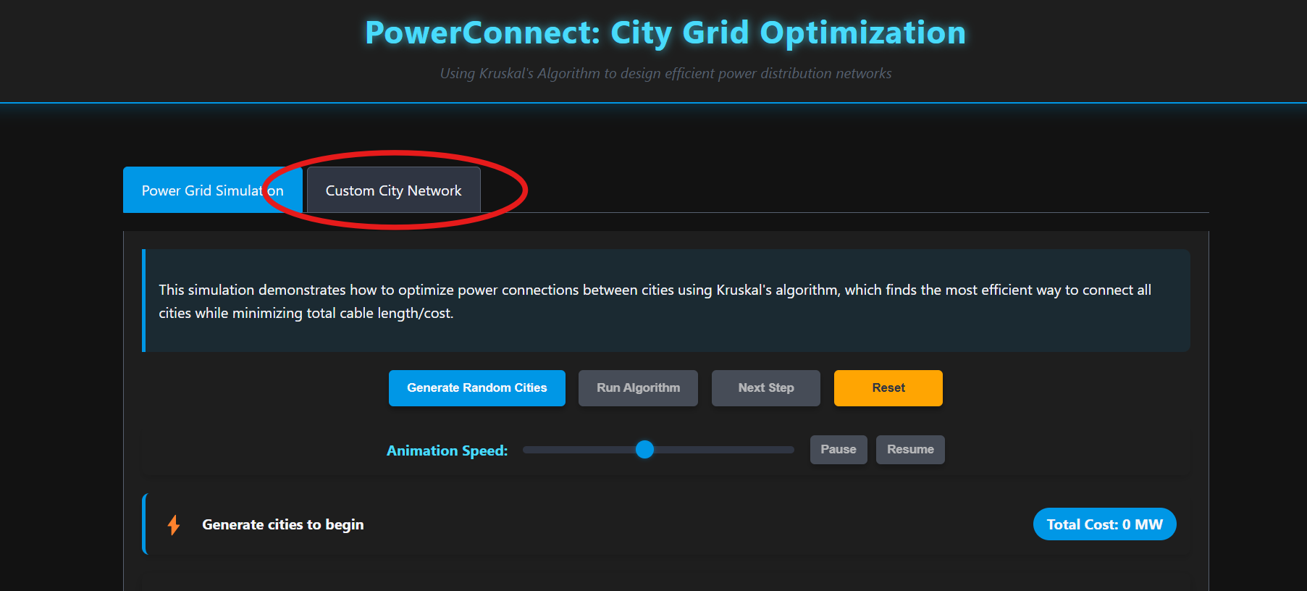

* Use:
  + “Add City” to place labeled cities

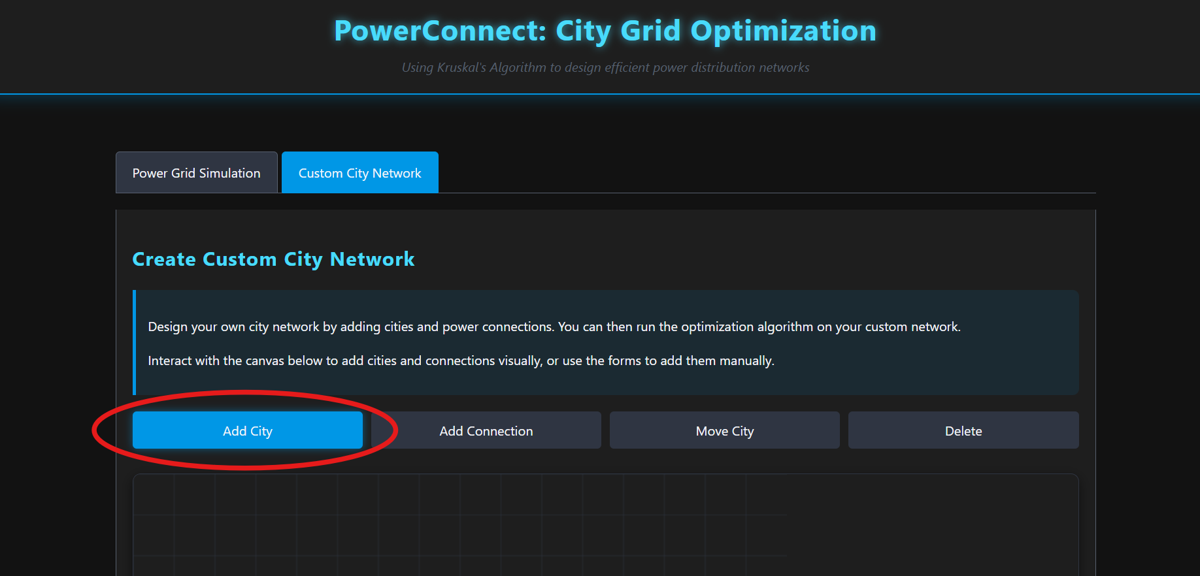

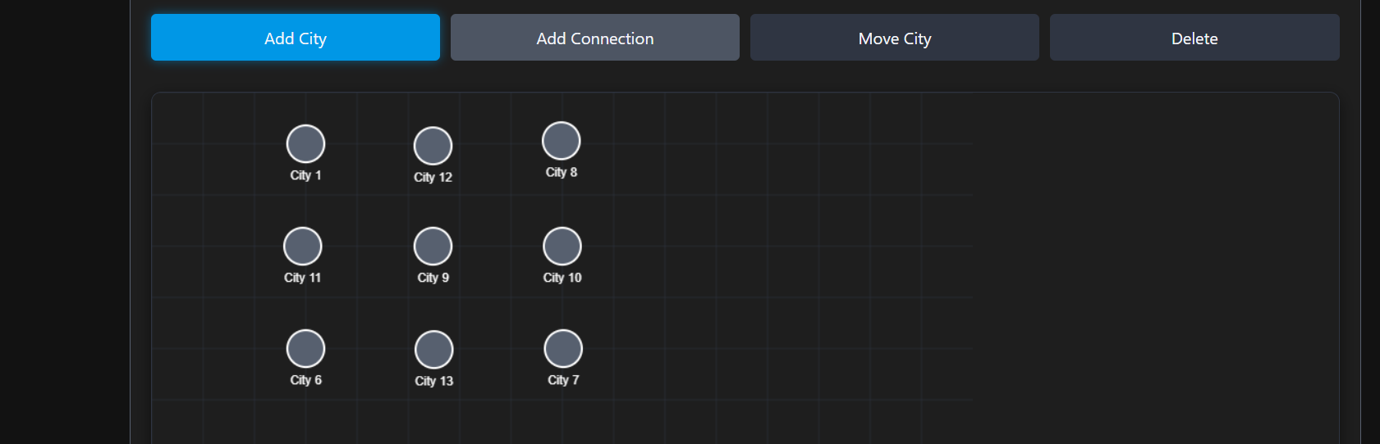

* + “Add Connection” to create links

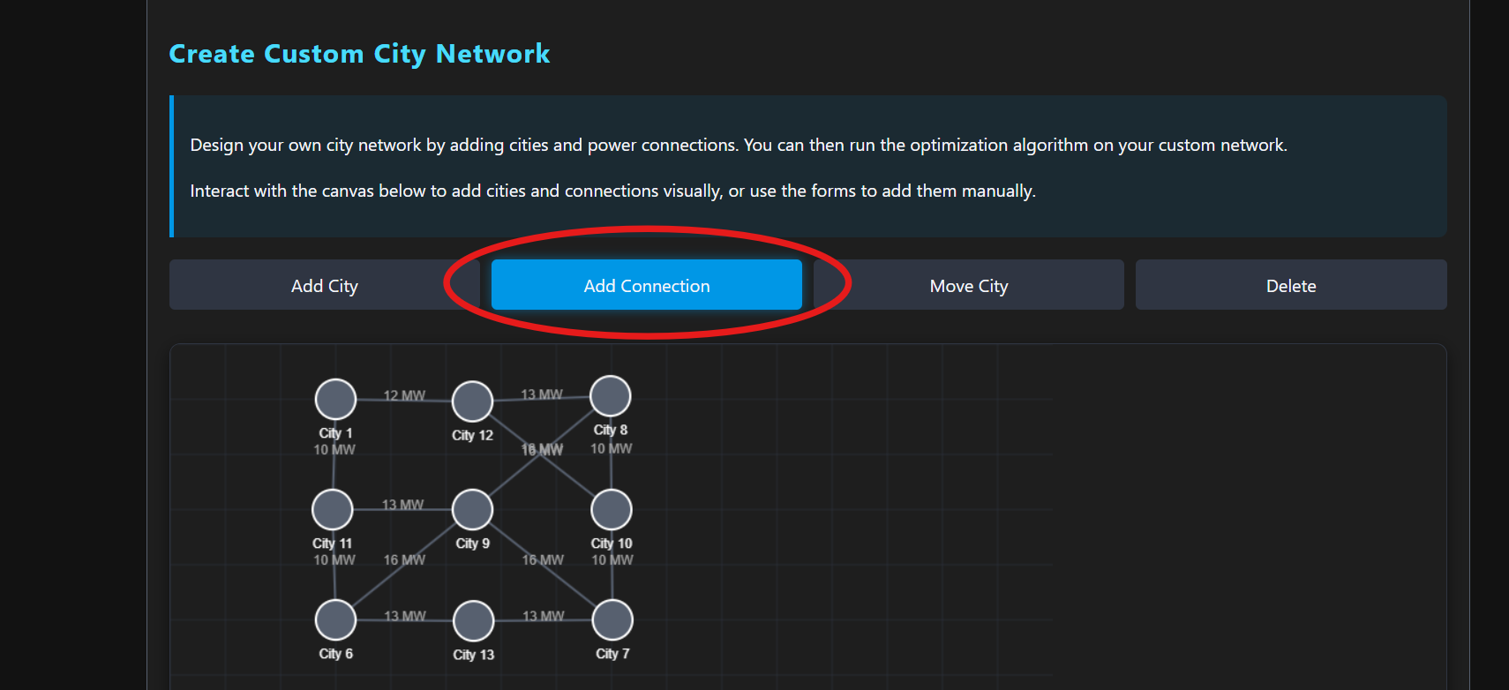

* + “Move City” to rearrange

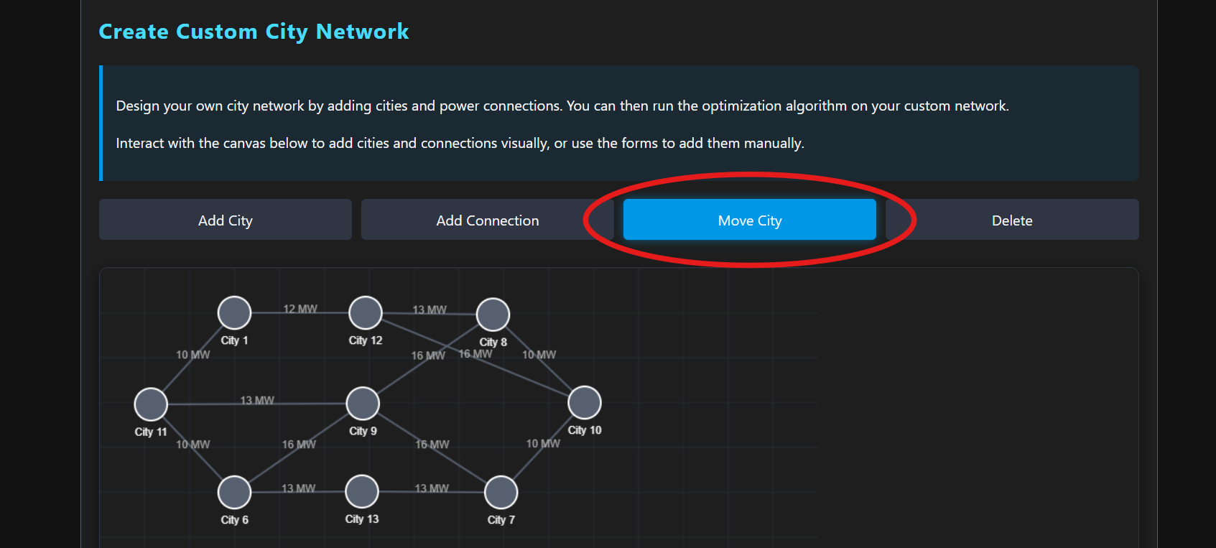

* + “Delete” to remove cities or edges

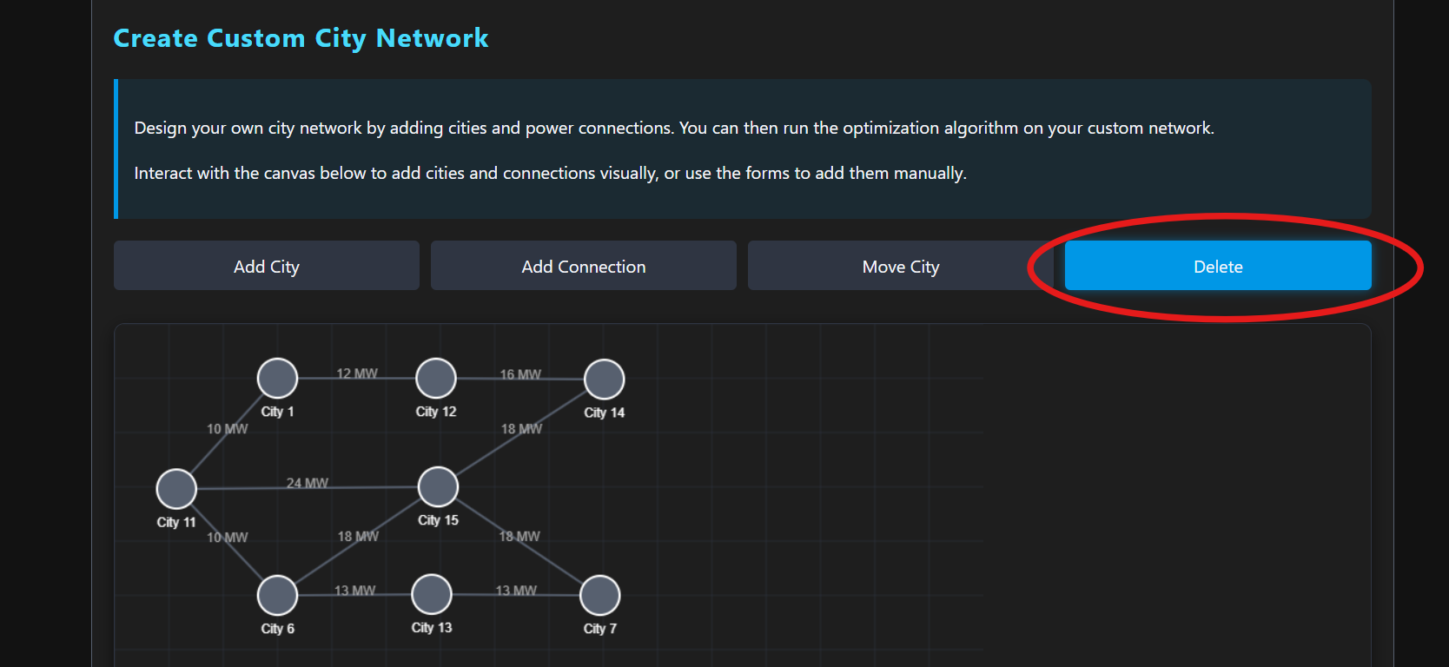

* Fill in the forms below the canvas to add nodes and edges manually.

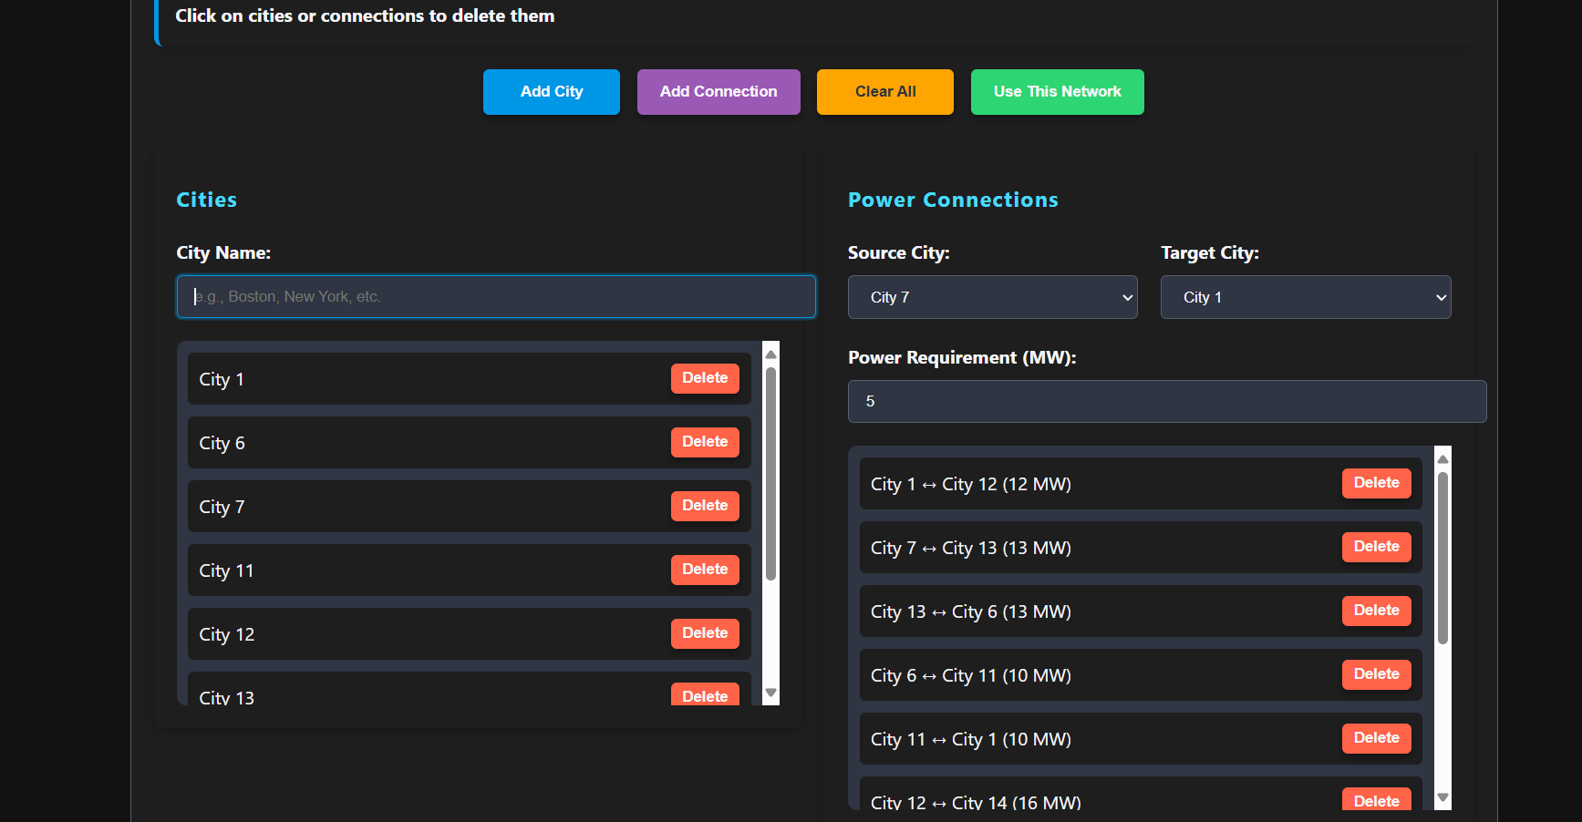

* Click Use This Network.



* This switches you to the simulation tab with your custom network loaded.

* Run the algorithm just like in the random simulation.

**E. Why This Application Is Useful**

Visualization:

The application transforms an abstract algorithm into a clear, interactive visual experience, making it easier to understand the logic behind Kruskal’s Algorithm and Minimum Spanning Trees.

Hands-on Interaction:

By allowing users to manually create and modify city networks, the application supports active learning and experimentation with different graph configurations.

Educational Value:

This tool serves as a practical resource for students and educators studying graph theory, network optimization, and algorithm design. It demonstrates how theoretical concepts are applied in real-world scenarios like power grid planning.

Flexible Exploration:

The dual modes (random simulation and custom input) allow users to explore both typical and edge-case scenarios, making the tool suitable for both guided demonstrations and independent investigations.

Problem-Solving Orientation:

The simulation encourages analytical thinking about how to build efficient infrastructure networks, highlighting trade-offs and constraints in optimization tasks.